SMART PUBLIC RESTROOM

|  |  |
| --- | --- |
| DATE | 12-11-2023 |
| PROJECT NAME | SMART PUBLIC RESTROOM |
| TEAM ID | Proj_220530_Team_1 |
| TEAM MEMBERS | D.BHUVANESHWARI  A.SARANYA  V.GAYATHRI  M.GOBIKA |

INTRODUCTION :

A smart restroom, also known as an intelligent restroom, is a technologically advanced facility that integrates various sensors, devices, and IoT technologies to enhance the overall restroom experience. These smart solutions are designed to address the challenges faced by traditional restrooms, such as cleanliness, efficiency, and user satisfaction.

By leveraging IoT technology, smart restrooms can collect and analyze real-time data on various aspects of restroom operations, including occupancy, cleanliness, supply levels, and maintenance requirements. This data-driven approach allows facility managers to make informed decisions, optimize resource allocation, and improve overall restroom .

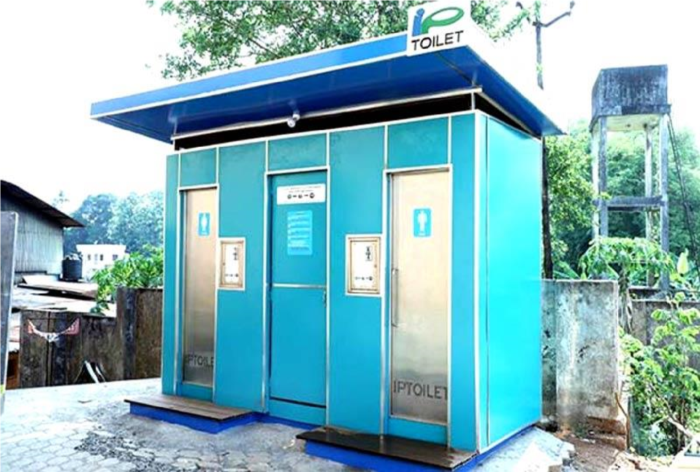

Smart public restroom

AI TO IMPROVE PUBLIC SMART RESTROOM:

With thousands of public toilets in cities, municipalities are confronted with inadequate monitoring capacity Imagine stepping out for a much-needed walk after an exhausting day. En route, you notice a few overflowing dustbins near a bus stop. The trend continues as you venture inside the park. After a few rounds, you decide to visit a public restroom and hold your breath. Indian public spaces face a chronic problem of waste mismanagement and dysfunctional utilities. People often resort to harmful measures like not drinking water or holding nature’s call.

This is where devices powered by the Internet of Things (IoT) can help. IoT is an ecosystem of physical objects that can communicate with each other, like smart dustbins with sensors that generate and transmit data on which a central system takes a decision to send the garbage pickup truck or penalise the vendor for not deploying the truck in time, etc.

Technology holds great promise for enhancing public satisfaction with urban environments. It can make cities healthier, more sustainable, and more inclusive for all residents.

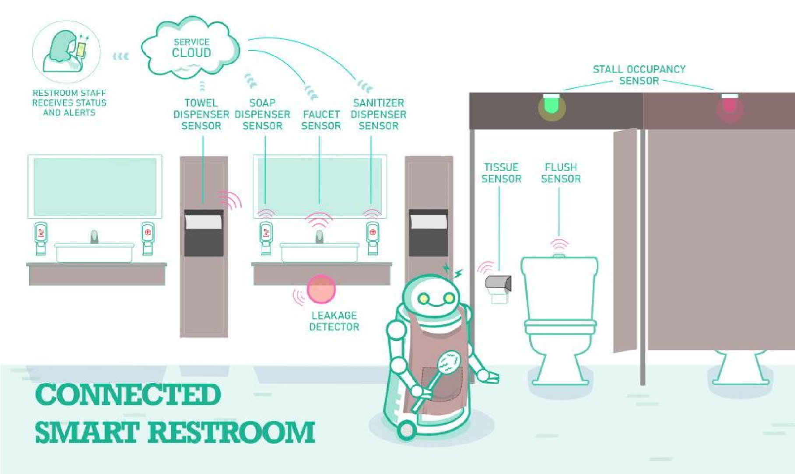

# ADS PUBLIC SMART RESTROOM:

Supreme Advertising was recently awarded the contract to set up 36 smart toilets as part of the Smart City project under the NDMC. The smart toilet complexes are unique in that they will have a bank ATM, water ATM, blood testing facility, ST vending machine, soft drinks vending machine, Wi-Fi and free toilet facilitiesDelhi-based Supreme Advertising (formerly known as Hythro) was recently awarded the contract to set up 36 smart toilets as part of the Smart City project under the NDMC. The smart toilet complexes are unique in that they will have a bank ATM, water ATM, blood testing facility, ST vending machine, soft drinks vending machine, Wi-Fi and free toilet facilities.

The first such smart toilet has been completed by Supreme Advertising at the Chelmsford Club on Rafi Marg. The complex was inaugurated by Union Home Minister Rajnath Singh in the presence of several dignitaries including the LG of Delhi Meenakshi Lekhi. This project was being seen as a big boost to the Government’s ‘Swachh Bharat’ mission.

DAC smart public restroom:

DAC, which stands for "Digital Air Quality Control," is a technology that can be integrated into smart public restrooms to improve the overall restroom experience. Here are some related topics and features:

1. **Air Quality Monitoring:** DAC systems can continuously monitor air quality within the restroom. If the air quality drops below a certain threshold, it can automatically activate ventilation systems to ensure a fresh and odorfree environment.
2. **Occupancy Sensors:** Smart restrooms can use occupancy sensors to detect when someone enters or leaves. This information can be used to manage lighting, ventilation, and even indicate which stalls are available.
3. **Touchless Fixtures:** To promote hygiene, smart restrooms often feature touchless faucets, soap dispensers, and hand dryers.Thesereduce the risk of cross-contamination.
4. **Digital Signage:** Informative displays can be integrated to show realtime information such as the availability of stalls, estimated waiting times, or even local news and weather updates.
5. **Water Conservation:** DAC technology can help control water usage, ensuring toilets and urinals only flush when necessary. This contributes to water conservation efforts.
6. **Maintenance Alerts:** Smart restrooms can send maintenance alerts when fixtures are malfunctioning or need servicing, allowing for quicker response times to keep the facilities in good working order.
7. **User Feedback:** Some smart restrooms may have a feedback system that allows users to report issues or rate the cleanliness of the facilities. This data can be used to continually improve the restroom experience.
8. **Accessibility Features:** DAC-enabled restrooms can provide features like voice-activated controls or assistance for individuals with disabilities.

Smart public restrooms with DAC technology are designed to enhance user experience, improve hygiene, and provide valuable data for facility management. These features can make public restrooms more efficient, pleasant, and user-friendly.

Smart washrooms are among recent IoT solutions that are very soon to be implemented here and there. Such new generation restrooms are expected to significantly improve customer experience and employee well-being while also lower costs allocated to maintain equipment.

# IOT SMART PUBLIC RESTROOM:

Smart washrooms products do a lot. In particular, they maintain lavatory in the best condition by Optimizing refills: no more worries that towels or soap will run out at the worst moment. Sending notifications when maintenance is needed: no need for employees to check the state of things every 30-60 minutes as they get alerted as soon as supervision is required.Tracking presence: less time in queues since users always know when there is an unoccupied cubicle, which guarantees that all cubicles are used more or less equally.Detecting and reporting smoking activities at no smoking area.Notifying when bins are full.Providing predictive analytics based on real time information tracking.

Smart washrooms analyze a lot of statistical data that come later helpful for trends and patterns tracking, which allows managing equipment placing in the most convenient way. When everything is located efficiently, maintenance is done on demand, and refills are attended timely - customer experience rapidly improves. It has been proved that around 66% of consumers recommend this or that public place based on restrooms tidiness, thus, smart washroom solution presents all chances for business to boost its image.

Using IOT in restroom

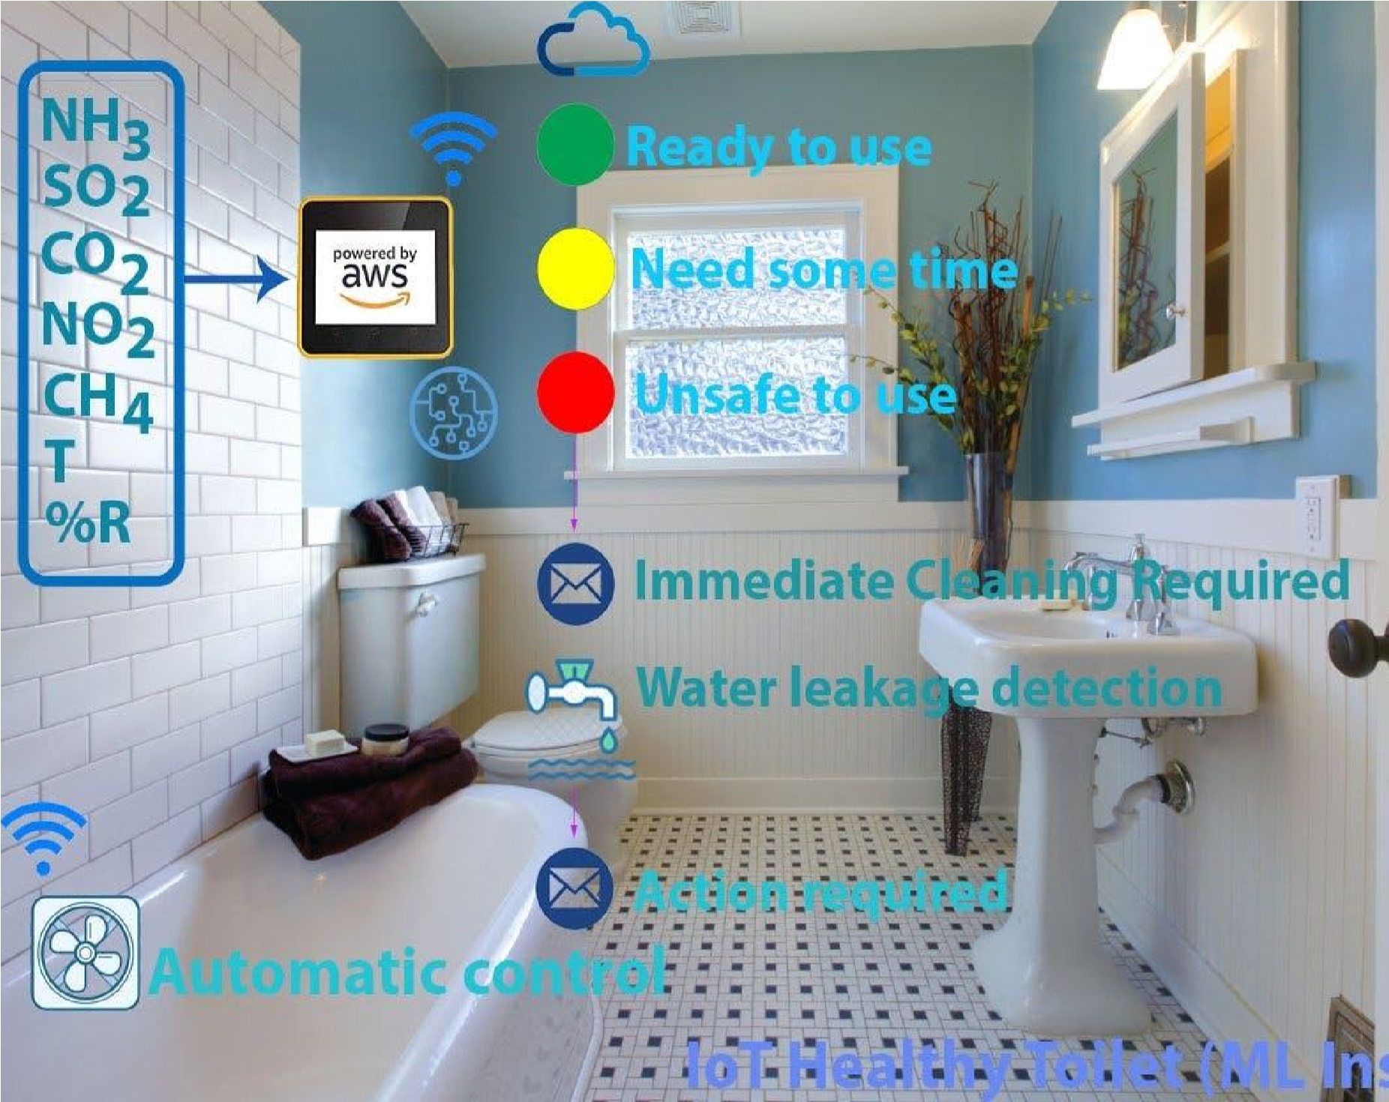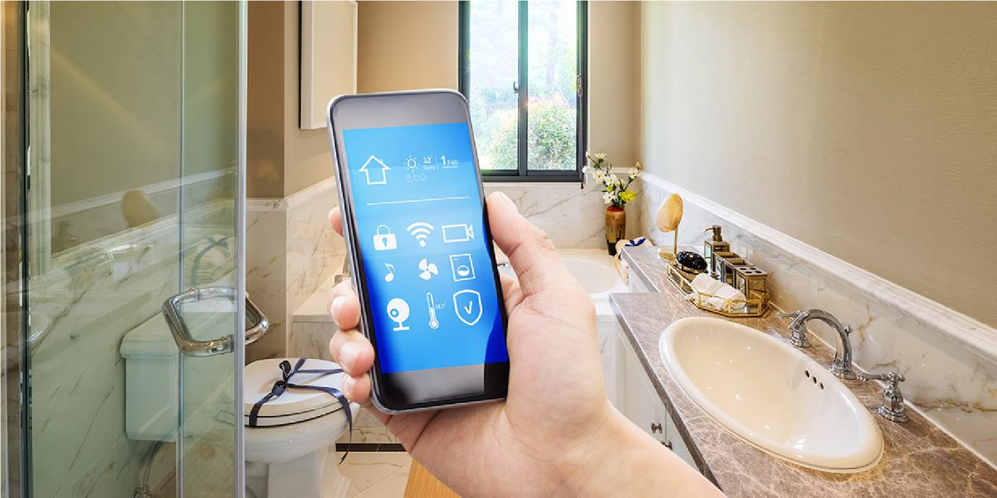

# CDA STARTS CONSTRUCTION OF PUBLIC TOILET IN THREE SECTORS:

At the direction of the Chairman of the Capital Development Authority (CDA), it was decided to build public toilets for special people throughout the city.Construction of the toilet was initiated by selecting three zones F-10, Area Blue, and I-8 Markaz. As a second step, toilets for special people will be set up in all areas of the city.

According to details, the Chairman of the Capital Development Authority (CDA), noticing the special people of the city, instructed the authorities to set up toilets for the special people, then issued decided to install toilets in three areas. Since the beginning of construction, in the three areas, toilets are equipped exclusively for ladies and gentlemen. Previously, also for the convenience of special people, ramps were created in all areas so that they could easily go to the market and shop without any difficulty. Ramps have been added at 40 locations for special people.

# FLOW CHART OF PUBLIC SMART RESTROOM:

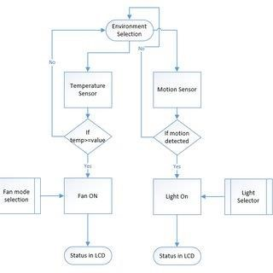

USING SENSORS :

Smell sensor

IR Sensor

Sonic sensor

RFID Sensor

PROGRAM IMPLEMENTATION :

#include <Servo .h>

#include < LiquidCrystal .h>

const int niagraMinDistance = 2;

const int niagraMaxDistance = 100;

const int trig = 7;

const int echo = 8;

const int servo = 9;

const int pingPin = 2;

const int echoPin = 3;

const int d4 = 4, d5 = 5, d6 = 6, d12 = 12;

const int rs = 10;

const int en = 11;

const int secondServo = 14;

long duration, distance, duration1, a[3];

float cm = 1.1;

Servo myServo;

Servo mySecondServo;

LiquidCrystal lcd(rs, en, d4, d5, d6, d12);

void setup() {

pinMode(pingPin, OUTPUT); // set ping Out

pinMode(echoPin, INPUT); // set echo In

lcd.begin(16, 2); // initialize LCD

Serial.begin(9600); // Initialize Serial

myServo.attach(servo);

mySecondServo.attach(secondServo);

pinMode(trig, OUTPUT);

pinMode(echo, INPUT);

myServo.write(180); // servo position 180 degree (can also be 0 if we want it to turn to the other way)

mySecondServo.write(180);

delay(1000);

myServo.detach();

mySecondServo.detach();

}

// Measures the distance from our hand to the the sensor

void measureServo() {

digitalWrite(trig, LOW);

delayMicroseconds(6);

digitalWrite(trig, HIGH);

delayMicroseconds(15);

digitalWrite(trig, LOW);

pinMode(echo, INPUT);

duration = pulseIn(echo, HIGH);

distance = (duration/2) / 29;

}

// Measures the distance from the float inside niagara to the sensor

void measureDistanceFloat() {

digitalWrite(pingPin, LOW);

delayMicroseconds(2);

digitalWrite(pingPin, HIGH);

delayMicroseconds(10);

digitalWrite(pingPin, LOW);

duration1 = pulseIn(echoPin, HIGH);

}

// Convert data from input pins to cm

long microsecondsToCentimeters(long microseconds) {

return microseconds / 29 / 2;

}

void printDistanceToLCD(int cm) {

lcd.clear();

lcd.setCursor(0, 0);

lcd.print("Progress until");

lcd.setCursor(0, 1);

lcd.print("full tank: ");

lcd.print((double)cm / (niagraMaxDistance - niagraMinDistance) * 100.0);

lcd.print("%");

}

void printDistanceToSerial(int cm) {

Serial.print(cm);

Serial.print(" cm");

Serial.println();

}

void loop() {

Serial.print("test");

measureDistanceFloat();

cm = microsecondsToCentimeters(duration1);

printDistanceToLCD(cm);

printDistanceToSerial(cm);

for (int i = 0; i <= 2; i++) {

measureServo();

a[i]=distance;

delay(50);

}

distance = (a[0] + a[1] + a[2]) / 3;

if (distance < 70) {

myServo.attach(servo);

mySecondServo.attach(secondServo);

delay(1000);

myServo.write(90); // Servo position 90 degree

mySecondServo.write(90);

delay(2000);

myServo.write(180); // Servo position 180 degree

mySecondServo.write(180);

delay(1000); // Waiting for the water to flush down

my Servo .detach();

}

}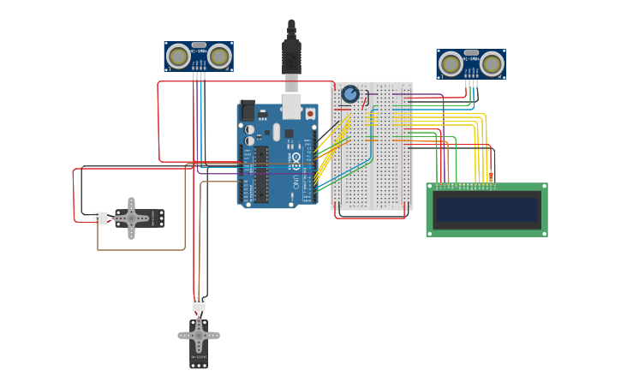

ADVANTAGES:

✓It can creates an awareness among the people about the proper toilet management

✓It can prevents the many contagious diseases like malaria, typhoid, cholera, streptococcus, asthma, etc..

✓It can promotes the “Swachhbharat” scheme

CONCLUSION:

Our proposed project will create awareness among the people about the proper sanitation. It makes use of Internet of things, which is a rapidly growing technology. Our proposed system will make everyone to strictly follow the cleanliness and proper sanitation in the toilets. It prevents the many new contagious diseases that spread due to improper sanitation of the toilets. Thus by using technologies in the smarter way, we can maintain the cleanliness which is next to the godliness.

keep Clean, Be Safe.